Soccer Predictions

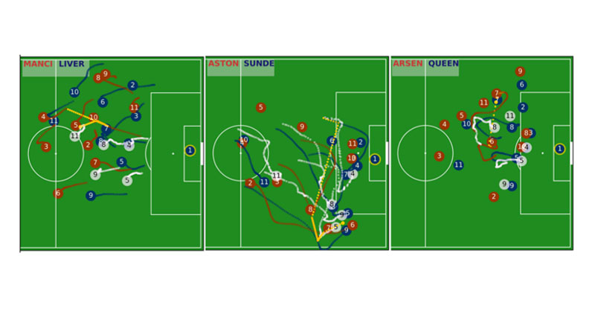
Project Goal
The goal of the project is understand how predictable is the “beautiful game” (soccer).
We will focus in European leagues (Spanish, English, Italian, German,etc).
We will explore what are features of teams, players, that are more important to decide a soccer match.
We will answer questions like:
1) How predictable is knowing the score of a match
2) What are the most predictable teams.
3) Which is the most predictable league
4) What are the most decisive players.

Data
data from:
* kaggle:
https://www.kaggle.com/mkhvalchik/soccer/data
https://www.kaggle.com/hugomathien/soccer
data of:
+25,000 matches
- +10,000 players
- 11 European Countries with their lead championship
- Seasons 2008 to 2016
- Players and Teams' attributes* sourced from EA Sports' FIFA video game series, including the weekly updates
- Team line up with squad formation (X, Y coordinates)
- Betting odds from up to 10 providers
- Detailed match events (goal types, possession, corner, cross, fouls, cards etc...) for +10,000 matches.
* Other Databases.

